Sovunh Voeu, George Zmudzien

Professor Poonam

COMP 470-001

11/6/2024

Topic: Natural Disasters Predictions Using Weather Data

The 5 different EDA operations I have done are:

1. **Structure Analysis** to identify outliers or any anomalies that may create problems for the data.

1. **Missing Value Analysis** to remove affected rows or chooses a suitable imputation that will target missing values that interfere.

1. **Univariate Analysis** to understand and normalize the distribution if needed through using histograms and box plots.

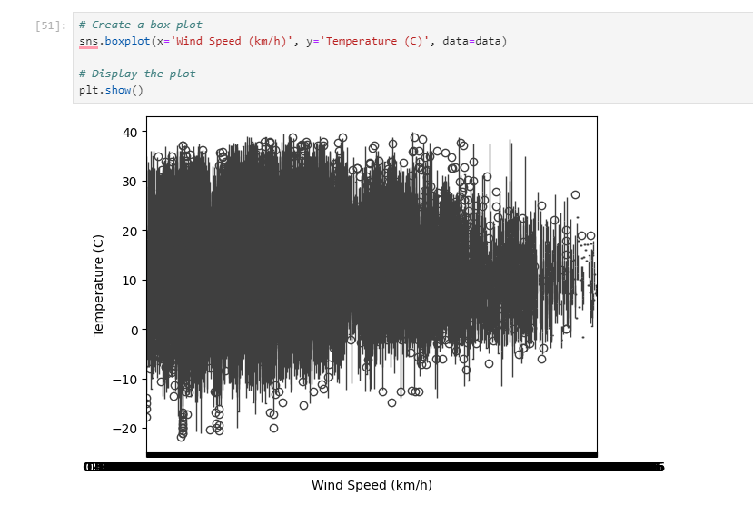

1. **Outlier Detection and Treatment Analysis** to avoid outliers that may skew the model and create a poor graph.

1. **Bivariate Analysis** to create scatter plots or heatmaps to further observe the relationship between pairs of variables.

The algorithm that I chose to use from machine learning that we did not discuss in class was the **Random Forest Algorithm**.

Works Cited:

GeeksForGeeks. 12 July 2024, www.geeksforgeeks.org/random-forest-algorithm-in-machine-learning/. Accessed 7 Nov. 2024.